[**#Kubernetes**](https://www.linkedin.com/feed/hashtag/?highlightedUpdateUrns=urn%3Ali%3Aactivity%3A6604589310748479488&keywords=%23Kubernetes&originTrackingId=N8R3yC627vavFfmDrqxJbA%3D%3D) lovers, this post is especially for you. This list should cover the whole damn thing on earth about Kubernetes.

1. The Game of PODs is a FREE fun and challenging set of challenges to be played on Kubernetes - [**http://bit.ly/2QPPixZ**](http://bit.ly/2QPPixZ)

2. Get an in-depth primer on this powerful system for managing containerized applications - [**http://bit.ly/34ipRt4**](http://bit.ly/34ipRt4)

3. Get hands-on experience with container orchestration - [**http://bit.ly/33dm4f7**](http://bit.ly/33dm4f7)

4. A hands-on introduction to Kubernetes by the OpenShift team - [**http://bit.ly/34fMuhC**](http://bit.ly/34fMuhC)

5. Get familiar with the concepts of Kubernetes - [**http://bit.ly/2Dh2sfq**](http://bit.ly/2Dh2sfq)

6. Scalable Microservices with Kubernetes - [**http://bit.ly/2KS2kr0**](http://bit.ly/2KS2kr0)

7. Kubernetes Webinars by Janakiram MSV - [**http://bit.ly/2qGOjpn**](http://bit.ly/2qGOjpn)

8. Getting Started with Google Kubernetes Engine - [**http://bit.ly/2XNcVZB**](http://bit.ly/2XNcVZB)

9. A curated list for excellent Kubernetes sources - [**http://bit.ly/2XL5ZMt**](http://bit.ly/2XL5ZMt)

Bookmark this post's link and have fun learning Kubernetes. Have a great day:)

**[[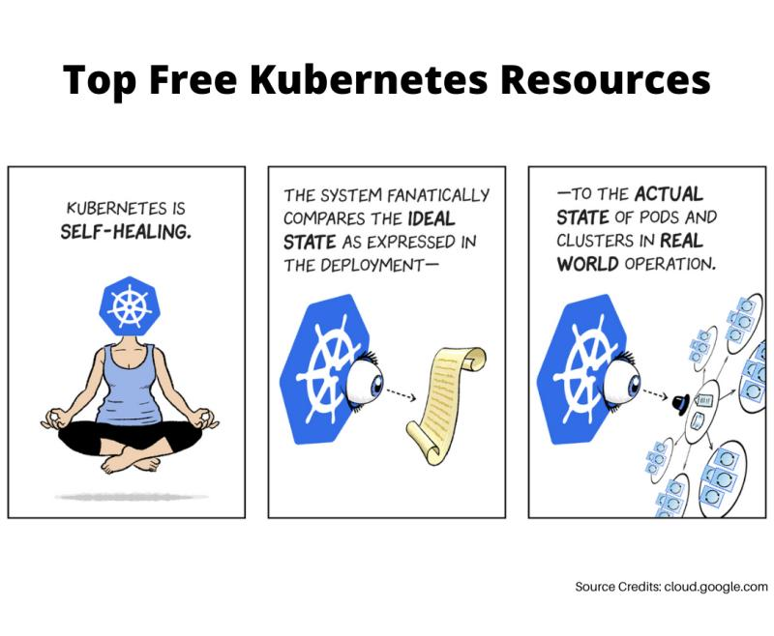](https://www.linkedin.com/feed/)](https://www.linkedin.com/feed/" \o "Kubernetes resources free" \t "_blank)**